Algebra 1: Unit 2, Lesson 9

- Simplify the expression $\frac{18xy^{6}}{9y^{3}}+\frac{3x}{9y^{3}}$.

$$2xy^{3}+\frac{x}{3y^{3}}$$

- When the greatest common factor, $k^{5}$, is factored out of the expression $6k^{7}+5k^{5}$, what is the quotient?

$$6k^{2}+5$$

- An area model of $(18m^{5}+12m^{3}-6m)÷3m$, where $m≠0$, is shown.
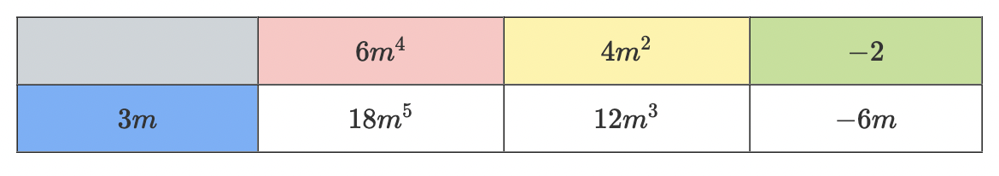
Using the area model, what is the quotient of $(18m^{5}+12m^{3}-6m)÷3m$, where $m≠0$?

$$6m^{4}+4m^{2}-2$$

